CSC500 Module 3: Critical Thinking Assignment

Part 1 – Generate Bill for the Food along with Tip (18%) and Tax (7%) with Input Validation
Pseudocode
BEGIN
IMPORT Decimal and InvalidOperation
START
SET TIP_PERCENT = 0.18
SET TAX_PERCENT = 0.07
SET MIN_AMOUNT = 0.01
SET MAX_AMOUNT = 100000.00
REPEAT
DISPLAY "Enter the charge for the food: "
READ user_input
REMOVE leading and trailing spaces
IF input is empty
DISPLAY "Error: Input cannot be empty."
CONTINUE
TRY convert input to decimal number
IF conversion fails
DISPLAY "Error: Invalid numeric value."
CONTINUE
IF food_charge <= 0
DISPLAY "Error: Amount must be greater than zero."
CONTINUE
IF food_charge < MIN_AMOUNT
DISPLAY "Error: Amount must be at least 0.01."
CONTINUE
IF food_charge > MAX_AMOUNT
DISPLAY "Error: Amount exceeds maximum limit."
CONTINUE
IF more than 2 decimal places
DISPLAY "Error: Only 2 decimal places allowed."
CONTINUE
UNTIL valid input is entered
CALCULATE Total Bill Amount
CALCULATE tip = food_charge × TIP_PERCENT
CALCULATE tax = food_charge × TAX_PERCENT
CALCULATE total = food_charge + tip + tax
DISPLAY food charge
DISPLAY tip amount
DISPLAY tax amount
DISPLAY total amount
END

Source Code
""""
Assignment 3 - Part 1
Restaurant Bill Calculator considering Tip & Tax along with Meal Charge
Author: Shadab
"""
# Python code for Restaurant Bill Calculator
# user provides Inputs at Runtime and also validations
from decimal import Decimal, InvalidOperation
# Define Constants
TIP_PERCENT = Decimal('0.18')
TAX_PERCENT = Decimal('0.07')
MIN_AMOUNT = Decimal('0.50')
MAX_AMOUNT = Decimal('10000.00')
# Function to Input and Validate food charge
def get_food_charge():
while True:
user_input = input('Enter the food charge: ').strip()
#Validations for the input provided
#Empty Input
if user_input == '':
print('Input value cannot be empty!! Please enter a valid food charge.\n')
continue
try:
food_charge = Decimal(user_input)
# Positive Input Value
if food_charge <= 0:
print(f'Invalid Input!! Please enter a valid amount greater than ${MIN_AMOUNT}.\n')
continue
# Minimum Input Value
if food_charge < MIN_AMOUNT:
print(f'Warning!! Amount entered must be at least ${MIN_AMOUNT}.\n')
continue
# Maximum Input Value
if food_charge > MAX_AMOUNT:
print(f'Warning!! Amount entered must be at most ${MAX_AMOUNT}.\n')
continue
# Number of Decimal places in the input value
if food_charge.as_tuple().exponent < -2:
print('Warning!! Please enter the Amount upto 2 decimal places.\n')
continue
return food_charge
except InvalidOperation:
print('Invalid Input!! Please enter only valid numerical amount.\n')
# Function to calculate the bill
def calculate_bill(food_charge):
tip_amount = (food_charge * TIP_PERCENT).quantize(Decimal('0.01'))
tax_amount = (food_charge * TAX_PERCENT).quantize(Decimal('0.01'))
total_bill = (food_charge + tip_amount + tax_amount).quantize(Decimal('0.01'))
return tip_amount, tax_amount, total_bill
# Function to generate the bill
def generate_bill(food_charge, tip_amount, tax_amount, total_bill):
print('\n****** Bill Summary ******\n')
print(f'Food Charge : {food_charge:.2f}')
print(f'Tip Amount (18%): {tip_amount:.2f}')
print(f'Tax Amount (7%) : {tax_amount:.2f}')
print(f'Total Bill : {total_bill:.2f}')
print('\n**************************\n')
def main():
food_charge = get_food_charge()
tip_amount, tax_amount, total_bill = calculate_bill(food_charge)
generate_bill(food_charge, tip_amount, tax_amount, total_bill)
if __name__ == '__main__':
main()

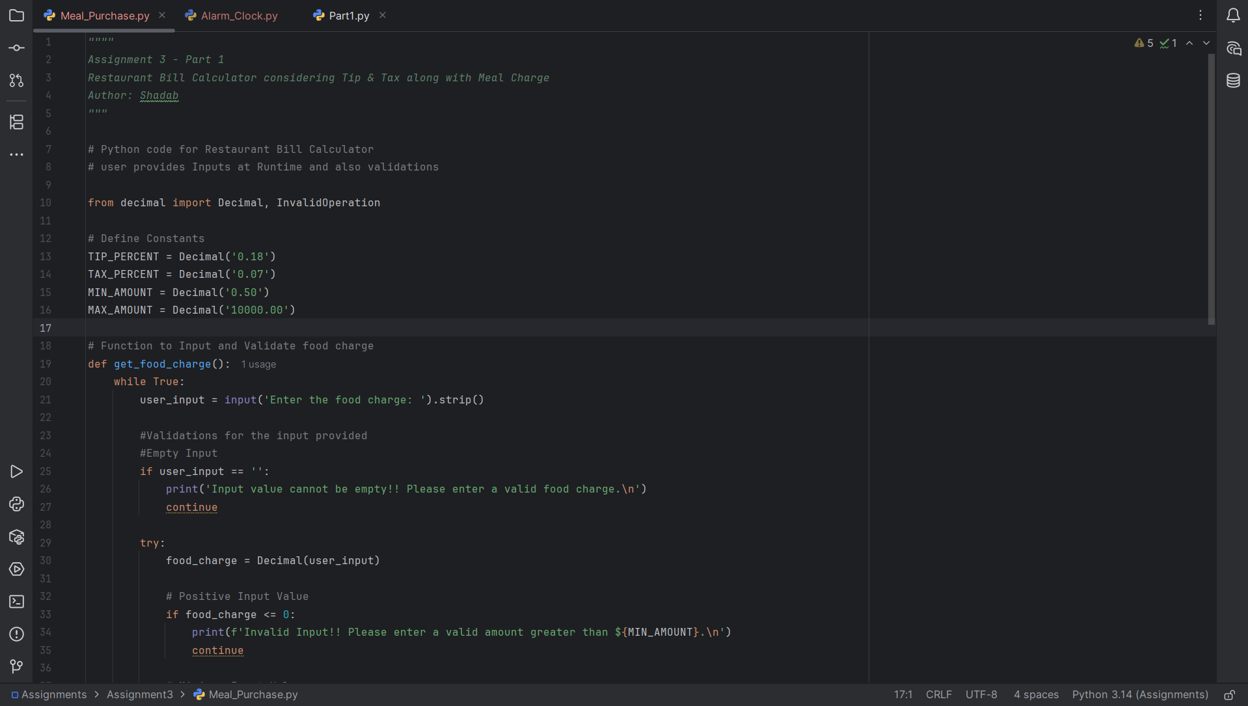

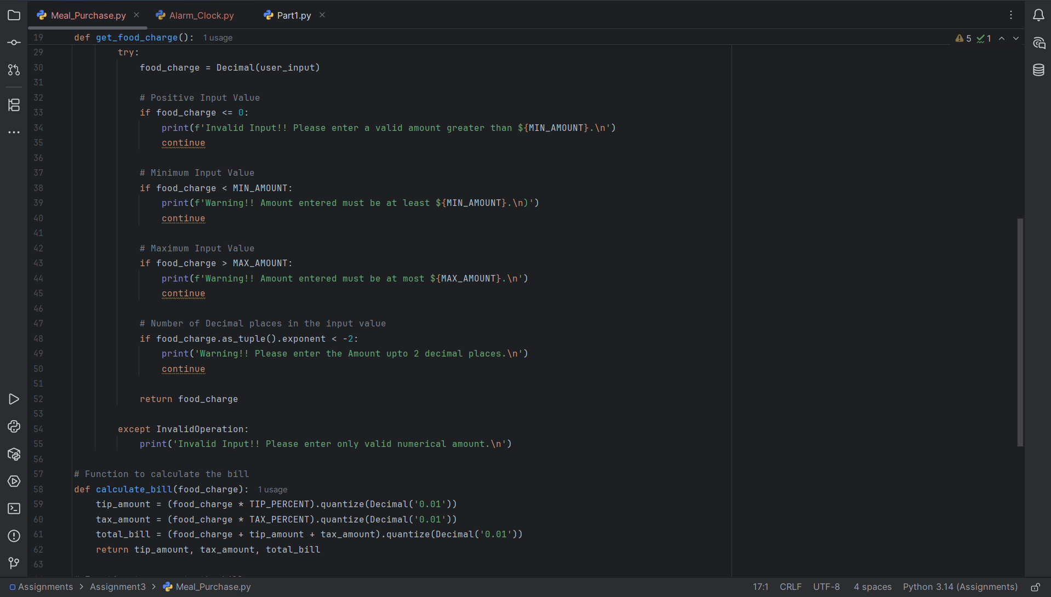

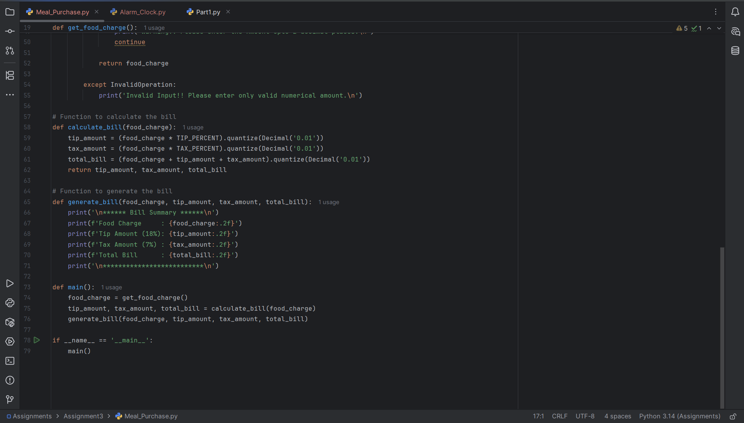

Program Execution Screenshots
Validation 1: When input is empty for food charge
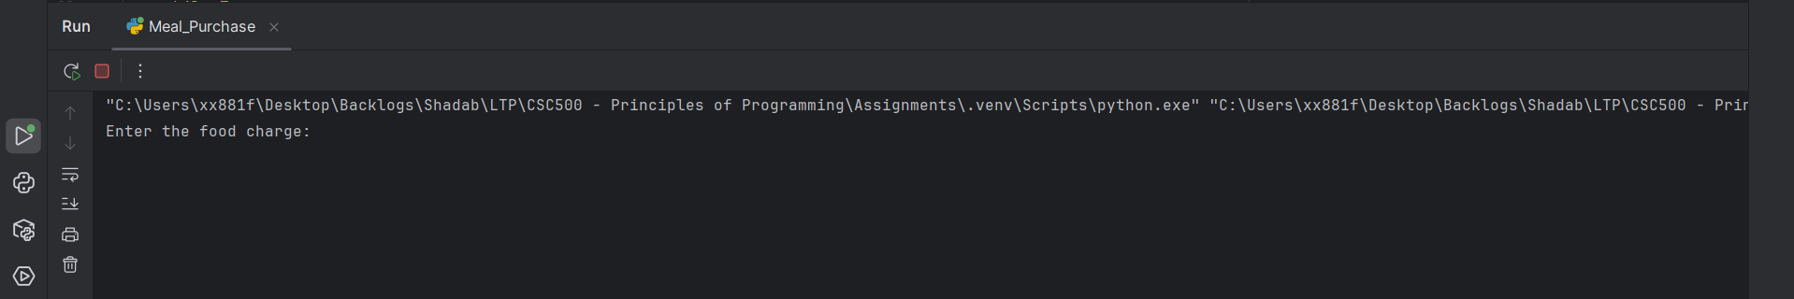

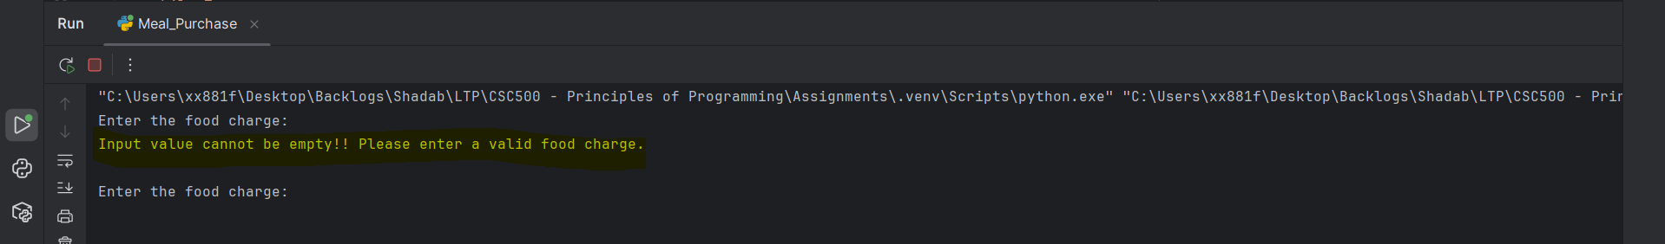

Validation 2: When input provided for food charge is strings
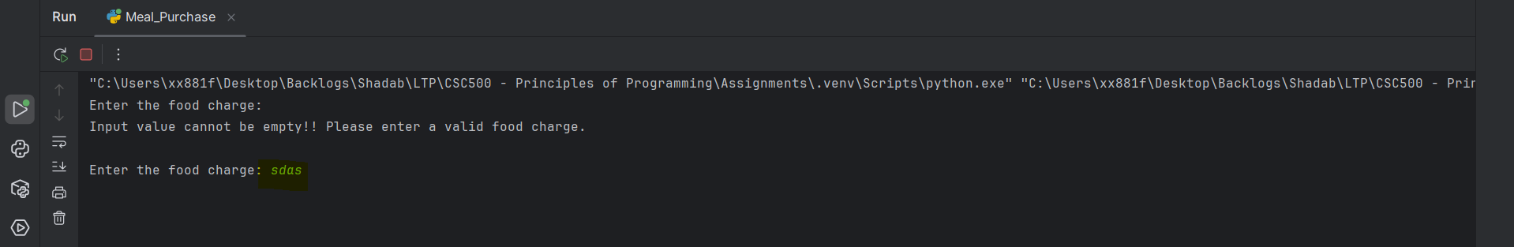

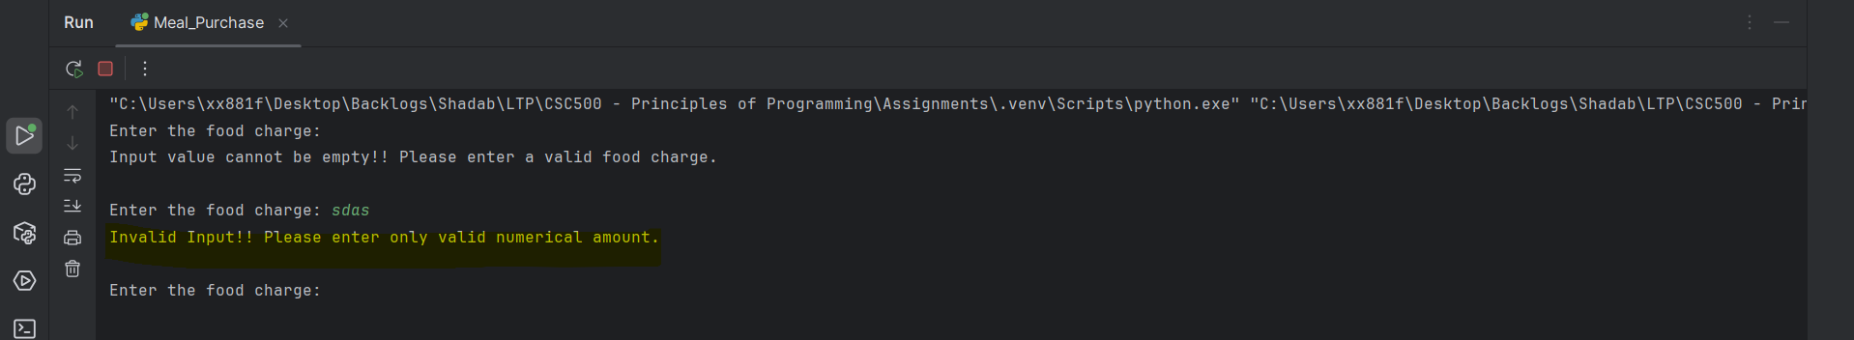

Validation 3: When food charge provided is less than min value and greater than max value set
Min Value = 0.50
Max Value = 10000
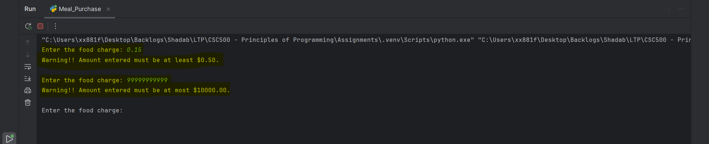

Validation 4: When food charge provided has more than 2 decimals
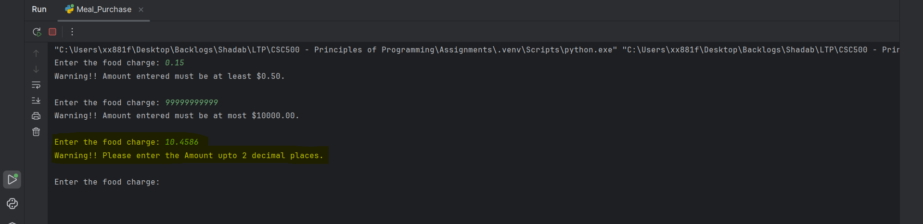

Validation 5: Bill Generation
Food Charge = 100.00
Tip = 18.00
Tax = 7.00
Total bill = 125.00
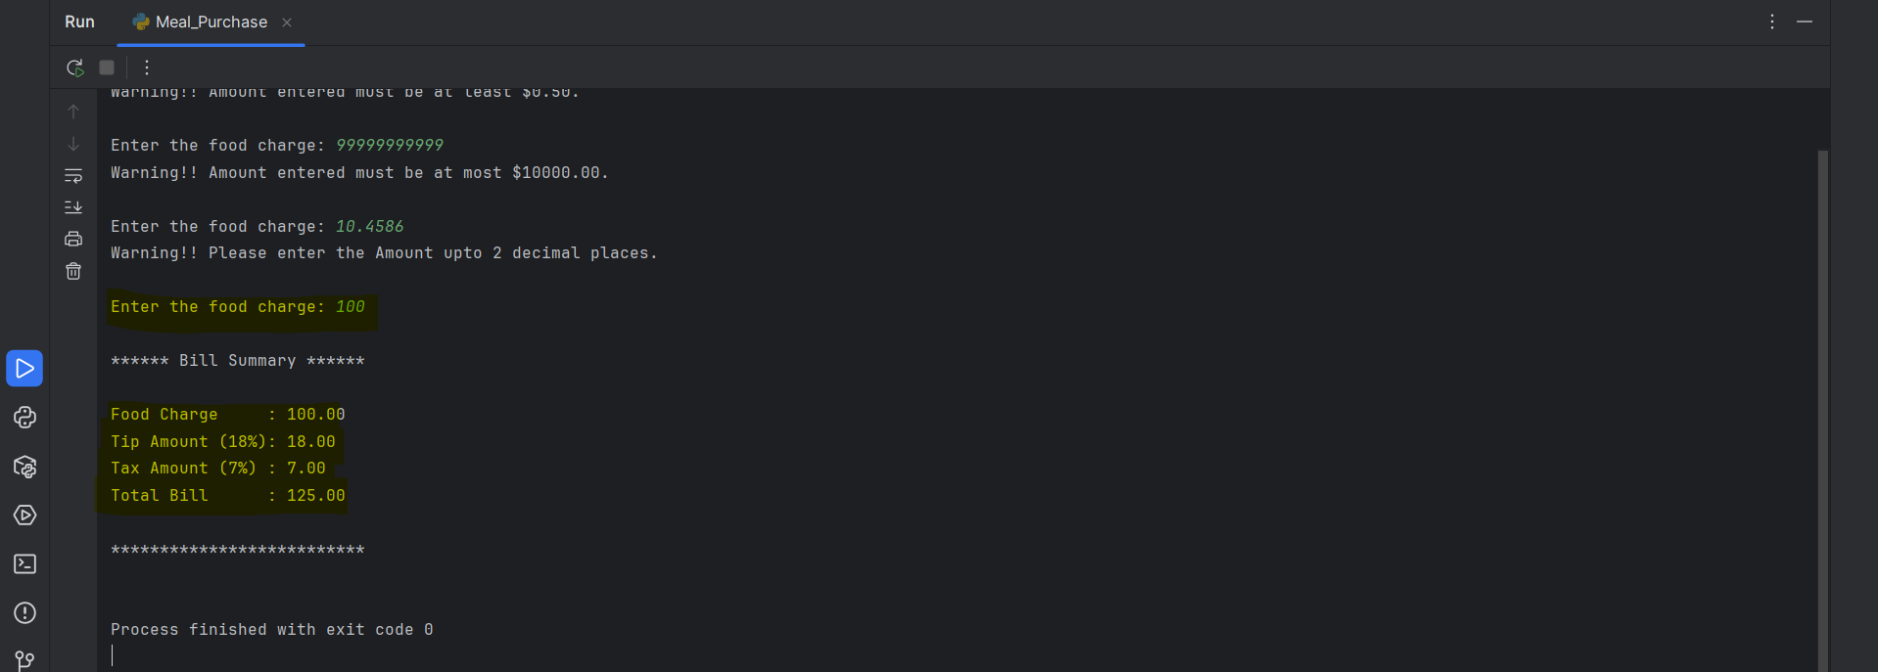

Part 2 - 24-Hour Alarm Clock Program with Input Validation
Pseudocode
START
REPEAT
PROMPT user to enter current time (0-23)
READ user_input
REMOVE leading and trailing spaces
IF input is empty
DISPLAY error message
CONTINUE
TRY convert input to integer
IF conversion fails
DISPLAY error message
CONTINUE
IF current_time < 0 OR current_time > 23
DISPLAY error message
CONTINUE
UNTIL valid current_time is entered
REPEAT
PROMPT user to enter number of hours to wait
READ user_input
REMOVE leading and trailing spaces
IF input is empty
DISPLAY error message
CONTINUE
TRY convert input to integer
IF conversion fails
DISPLAY error message
CONTINUE
IF wait_hours < 0
DISPLAY error message
CONTINUE
UNTIL valid wait_hours is entered
CALCULATE alarm_time = (current_time + wait_hours) MOD 24
CONVERT current_time to 12-hour format
CONVERT alarm_time to 12-hour format
DISPLAY:
Current Time (24-hour format HH:00)
Current Time (12-hour format HH:00 AM/PM)
Wait Time
Alarm Time (24-hour format HH:00)
Alarm Time (12-hour format HH:00 AM/PM)
END

Source Code
""""
Assignment 3 - Part 2
24-Hour Alarm Clock Program
Author: Shadab
"""
# Python code for 24-Hour Alarm Clock Program - With AM/PM Display
# user provides Inputs at Runtime and also validations
#Function to input and Validate Current time
def get_current_time():
while True:
user_input = input('Enter current time (0-23): ').strip()
# Validations for the input provided
# Empty Input
if user_input == '':
print('Input value cannot be empty!! Please enter a valid time.\n')
continue
# Enter value must be integer
try:
current_time = int(user_input)
except ValueError:
print('Warning!! Please enter a valid Integer Value.\n')
continue
# Enter value must be within the range of 0 to 23
if current_time < 0 or current_time > 23:
print('Warning!! Current time must be between 0 and 23.\n')
continue
return current_time
#Function to input and Validate wait hours
def get_wait_time():
while True:
user_input = input('Enter number of hours to wait: ').strip()
# Validations for the input provided
# Empty Input
if user_input == '':
print('Input value cannot be empty!! Please enter a valid number.\n')
continue
# Enter value must be integer
try:
wait_hours = int(user_input)
except ValueError:
print('Warning!! Please enter a valid Integer Value.\n')
continue
# Validation for negative values
if wait_hours < 0:
print('Invalid Input!! Hours to wait cannot be negative.\n')
continue
return wait_hours
# Function to calculate alarm time
def calculate_alarm_time(current_time, wait_hours):
return (current_time + wait_hours) % 24
# Function to conver 24-hour to 12-hour format
def convert_to_12_hour_format(hour):
if hour == 0:
return 12, 'AM'
elif 1 <= hour < 12:
return hour, 'AM'
elif hour == 12:
return 12, 'PM'
else:
return hour - 12, 'PM'
def main():
current_time = get_current_time()
wait_hours = get_wait_time()
alarm_time = calculate_alarm_time(current_time, wait_hours)
current_12_format, current_period = convert_to_12_hour_format(current_time)
alarm_12_format, alarm_period = convert_to_12_hour_format(alarm_time)
hour_label = 'hr' if wait_hours == 1 else 'hrs'
print("\n************ Alarm Summary ************\n")
print(f'Current Time (24-hour) : {current_time:02d}:00\n')
print(f'Current Time (12-hour) : {current_12_format:02d}:00 {current_period}\n')
print(f'Wait Time (in hours) : {wait_hours} {hour_label}\n')
print(f'Alarm Time (24-hour) : {alarm_time:02d}:00\n')
print(f'Alarm Time (12-hour) : {alarm_12_format:02d}:00 {alarm_period}\n')
print("\n**************************************\n")
if __name__ == '__main__':
main()
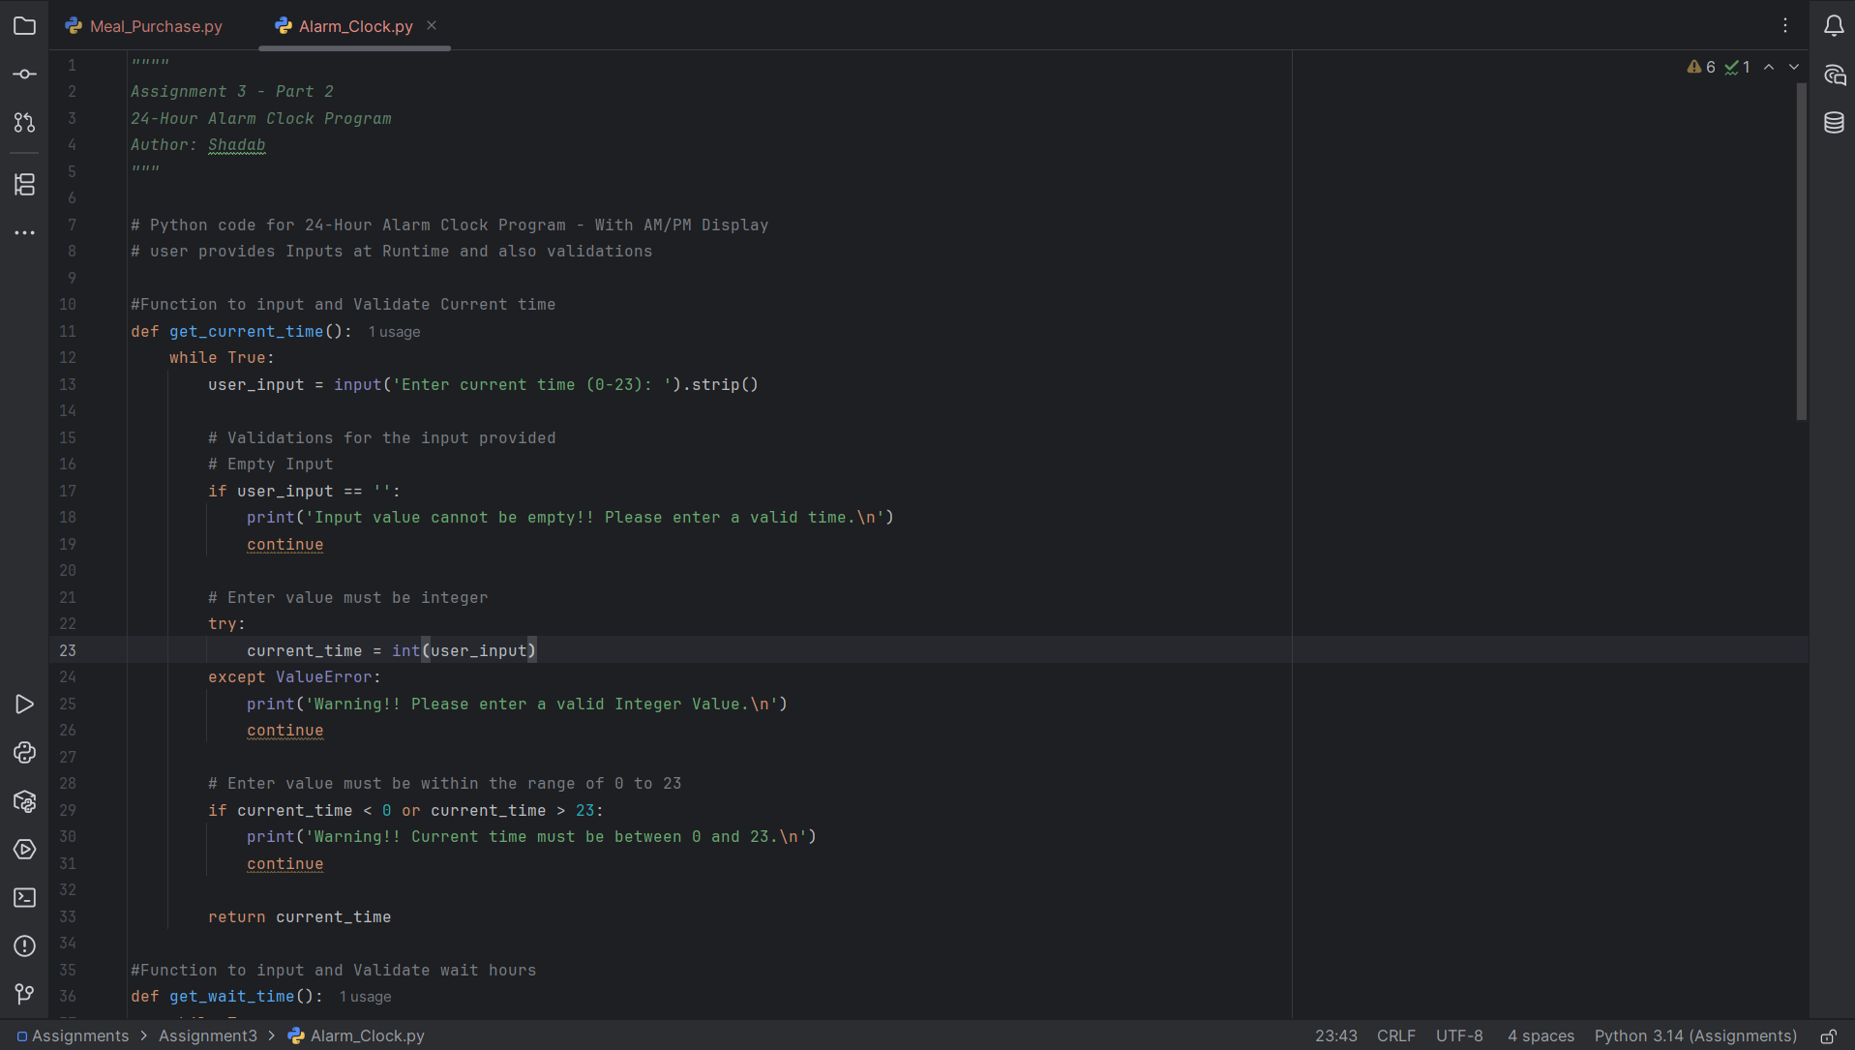

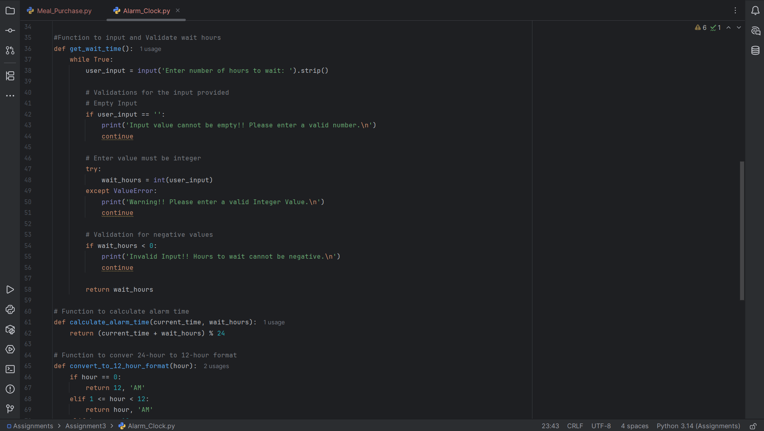

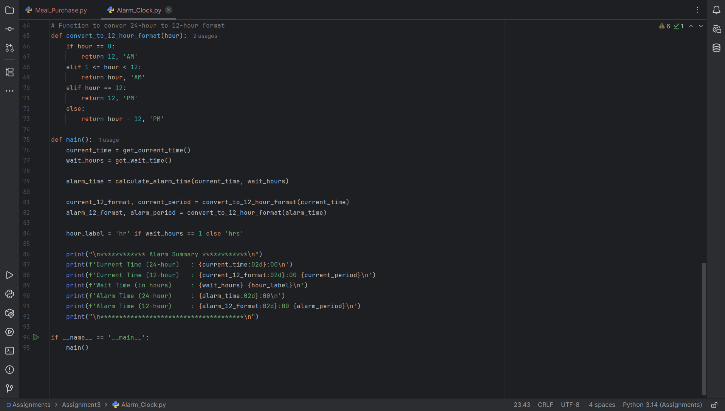

Program Execution Screenshots

Validation 1: When current time input is empty
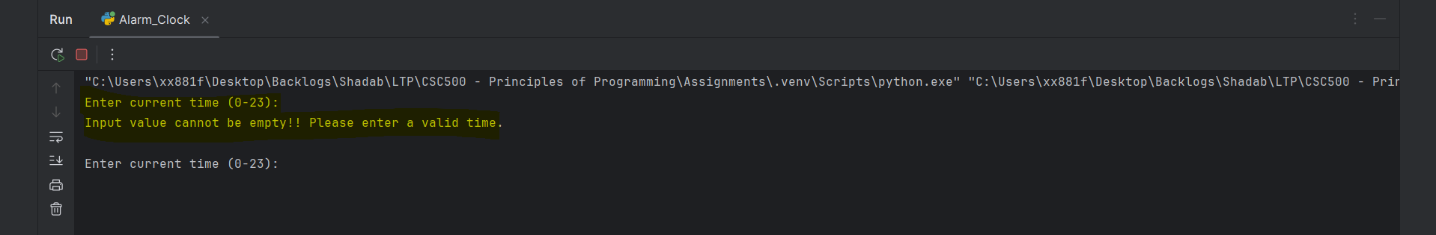

Validation 2: When current time input is strings
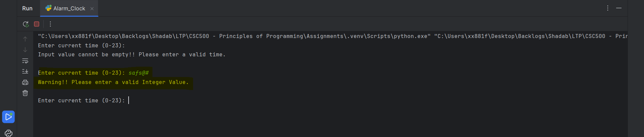

Validation 3: When current time input value must be within the range of 0 to 23
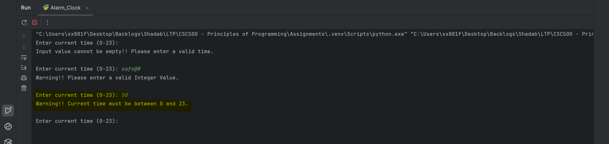

Validation 4: When number of hours to wait input is empty
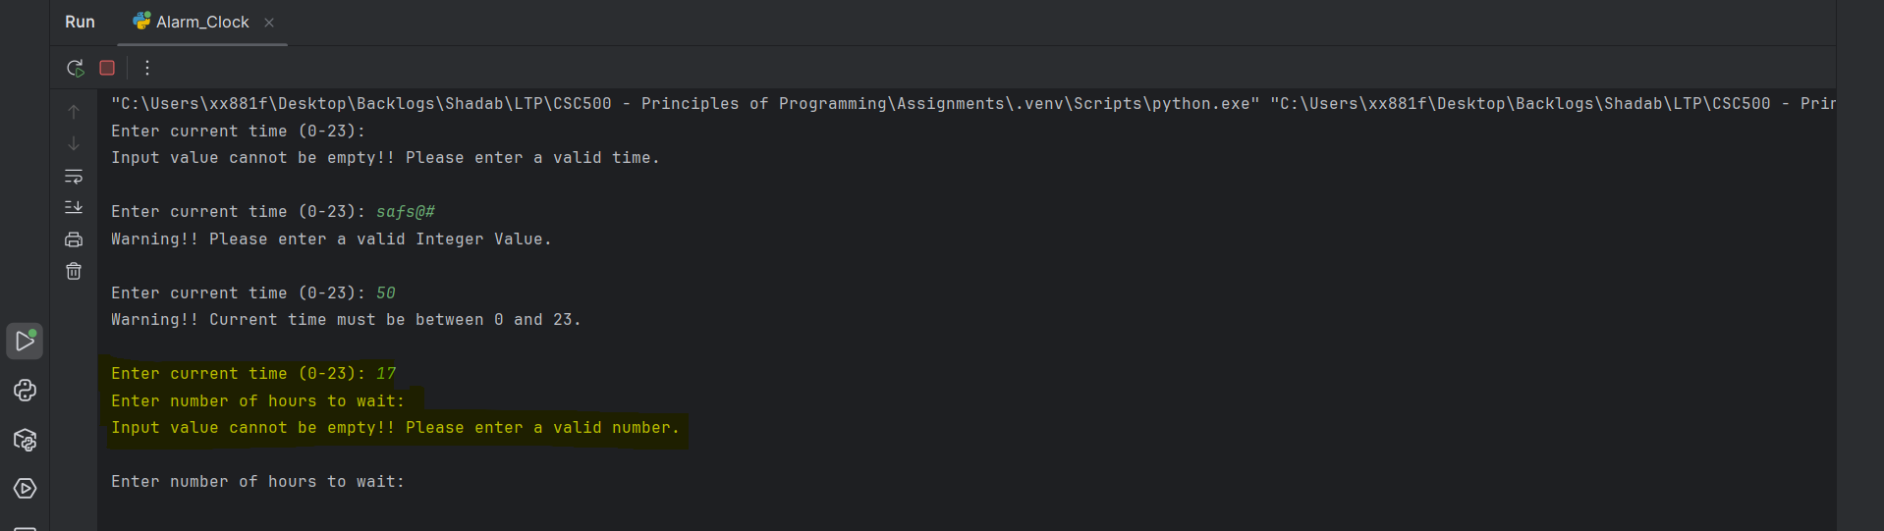

Validation 5: When number of hours to wait input is strings
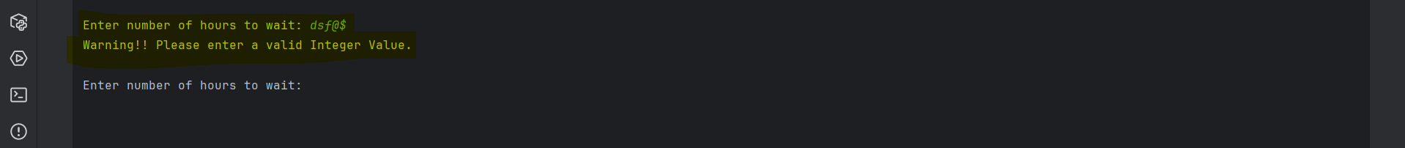

Validation 6: When number of hours to wait input is negative
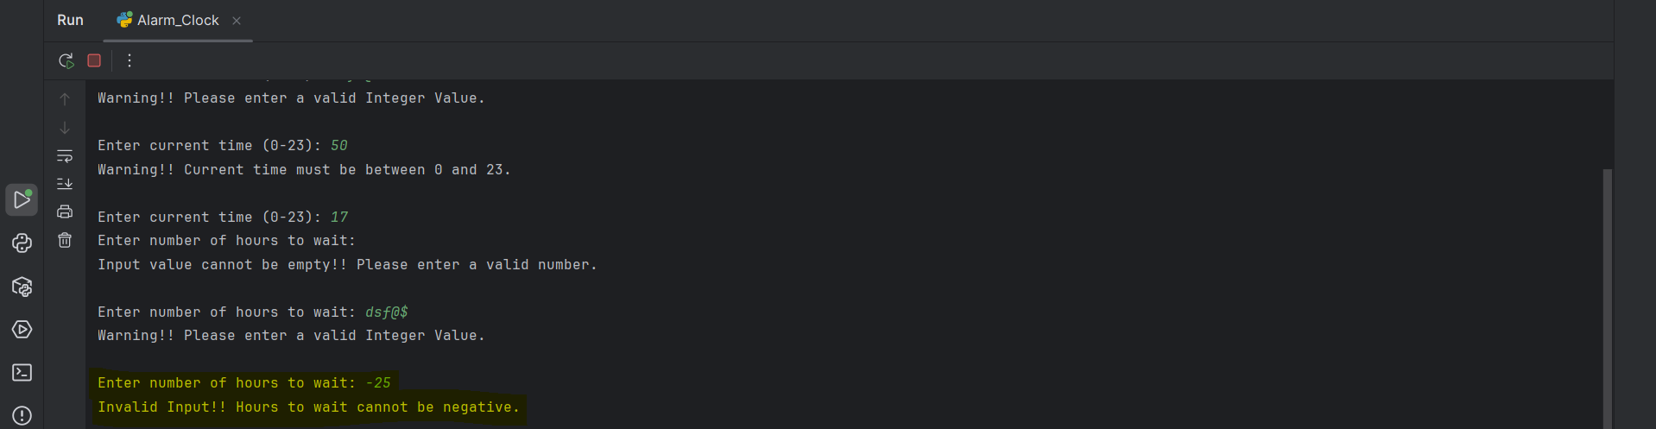

Validation 7: When number of hours to wait input has decimal values
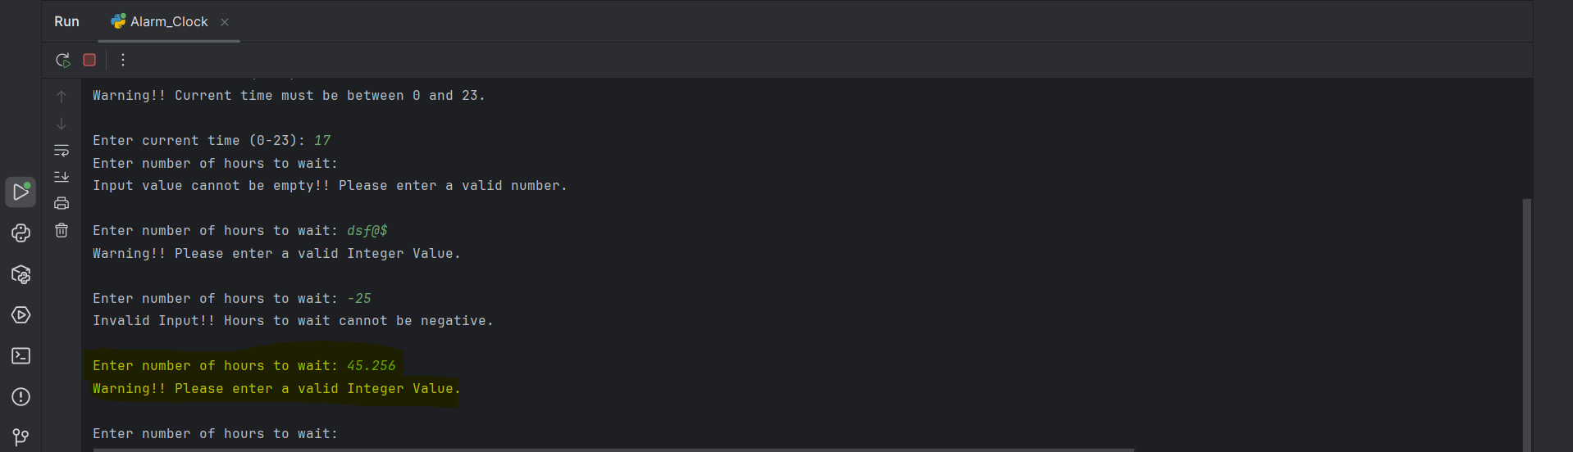
Validation 8: Calculating Alarm Time
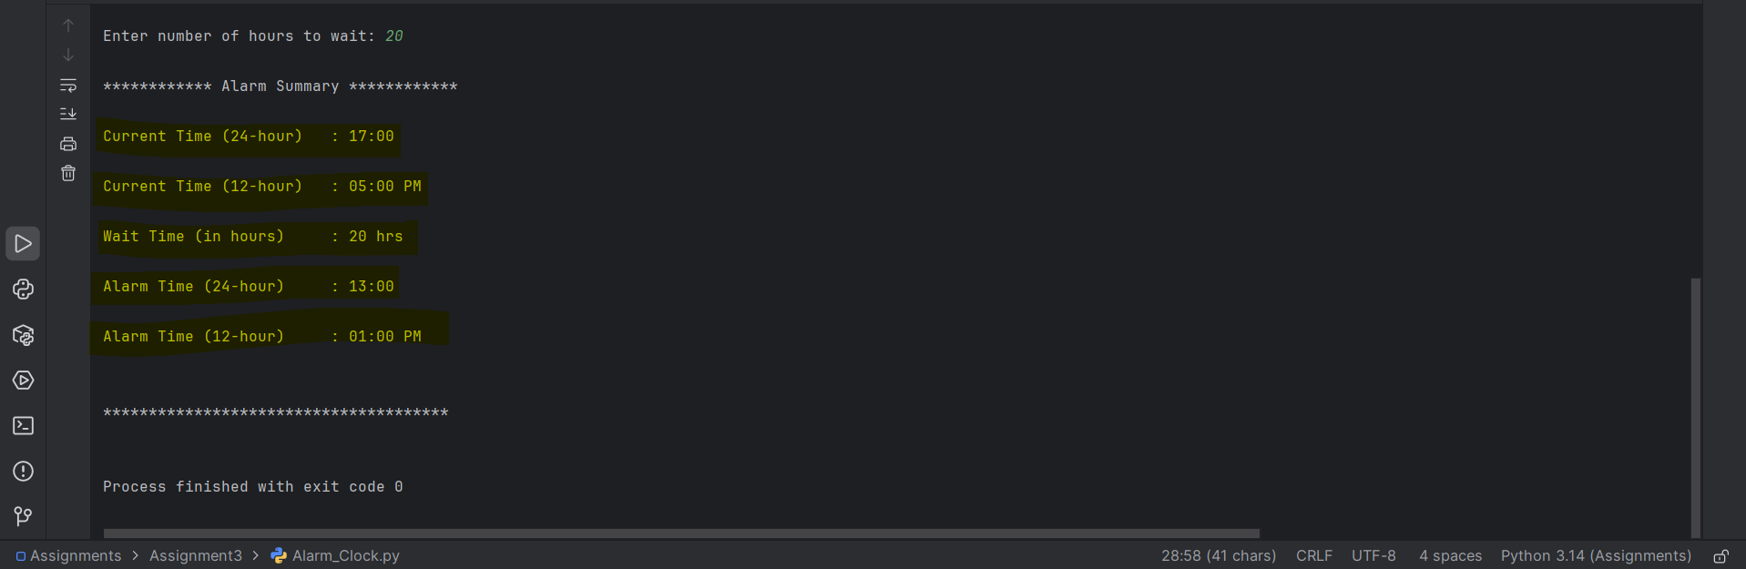

Part 3 – Git Repository
Created a Git-Hub Account with Repository name as “CSC500---Principles-of-Programming”
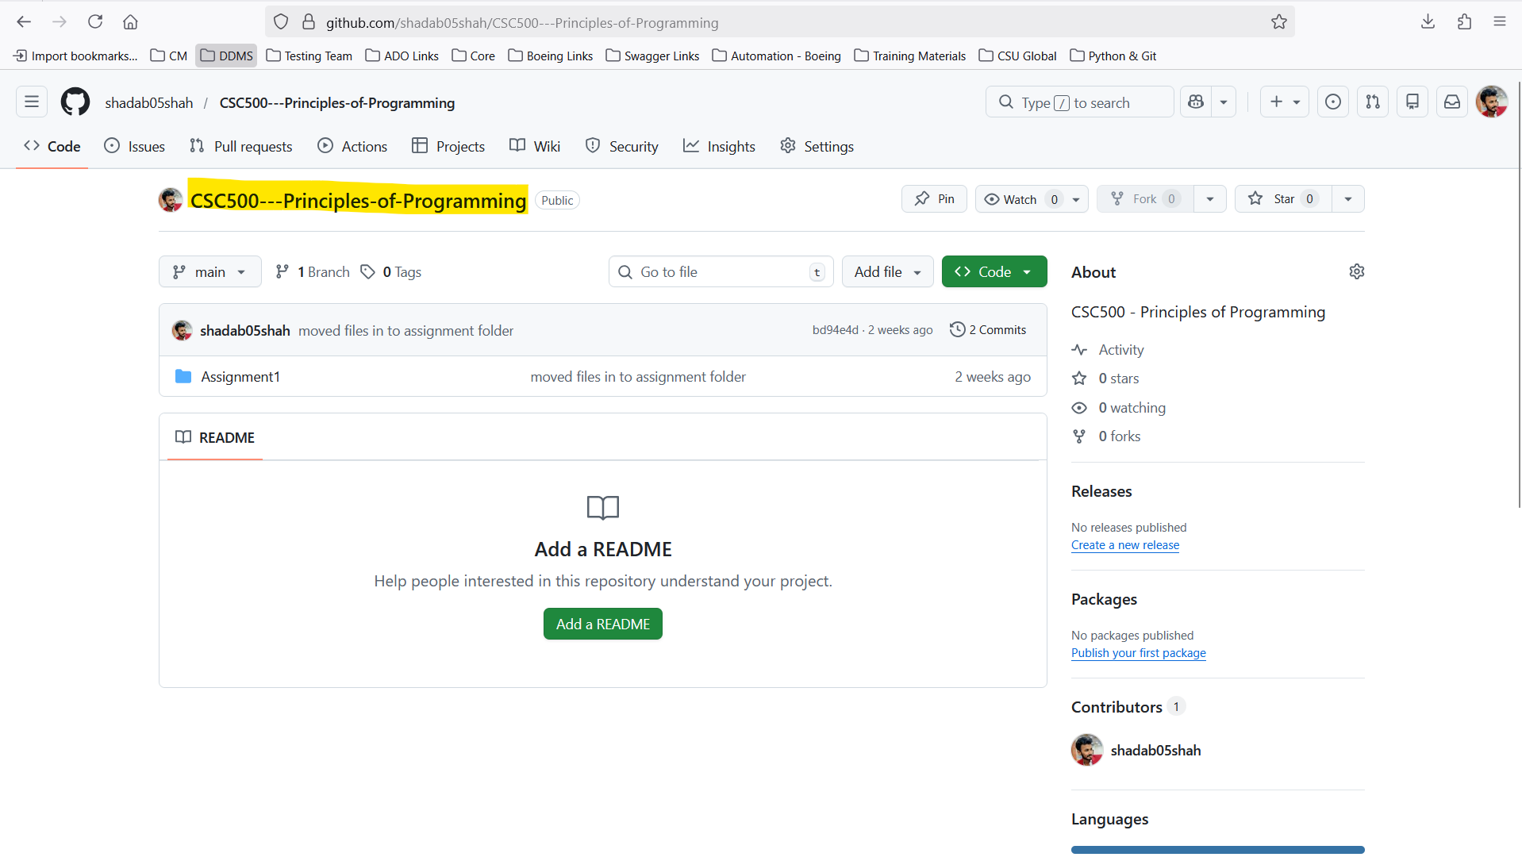

Main Project Folder Structure in Local
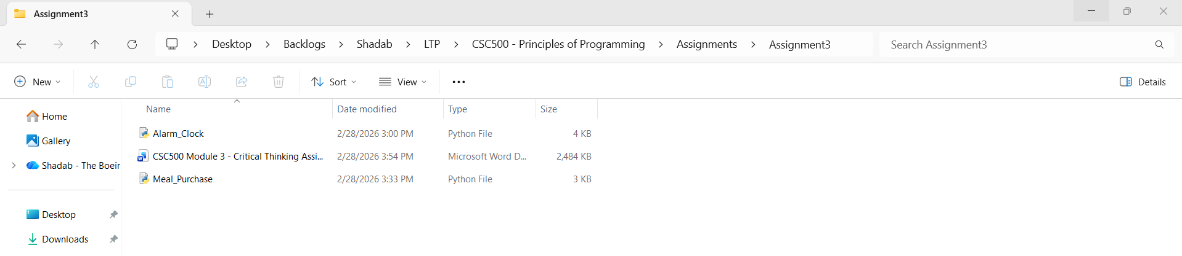

Initialize Git using “git status”
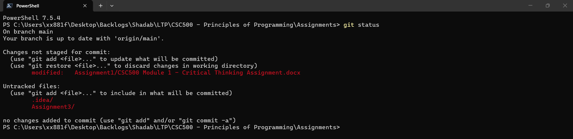

Ignore .idea folder
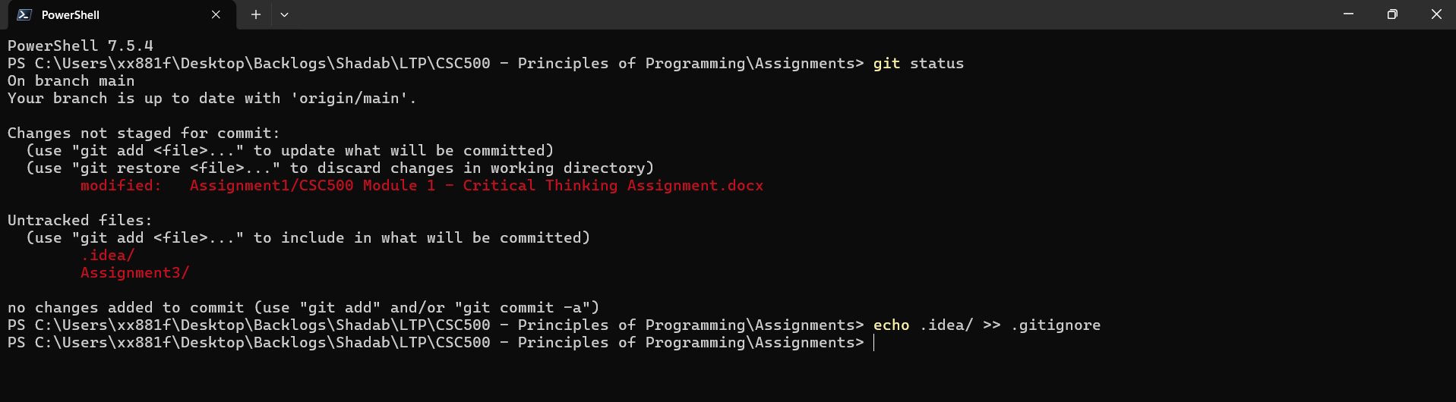

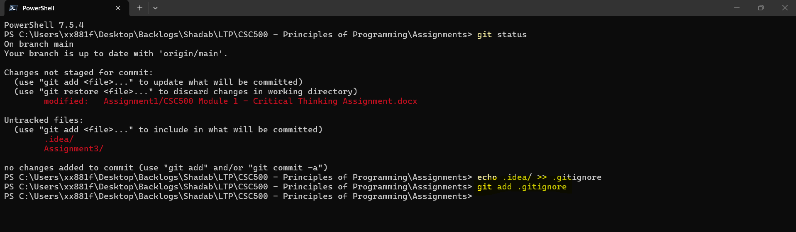

Adding only Assignment3 folder
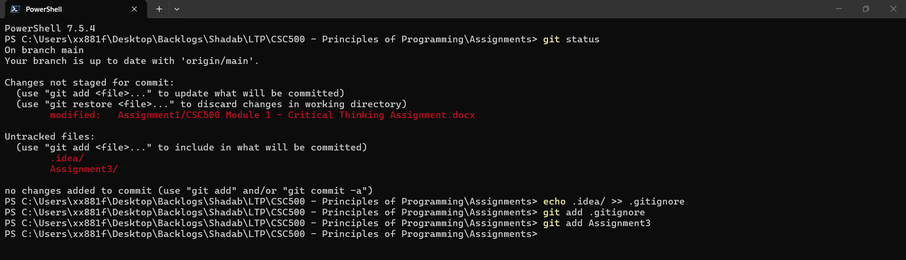

Commit Changes
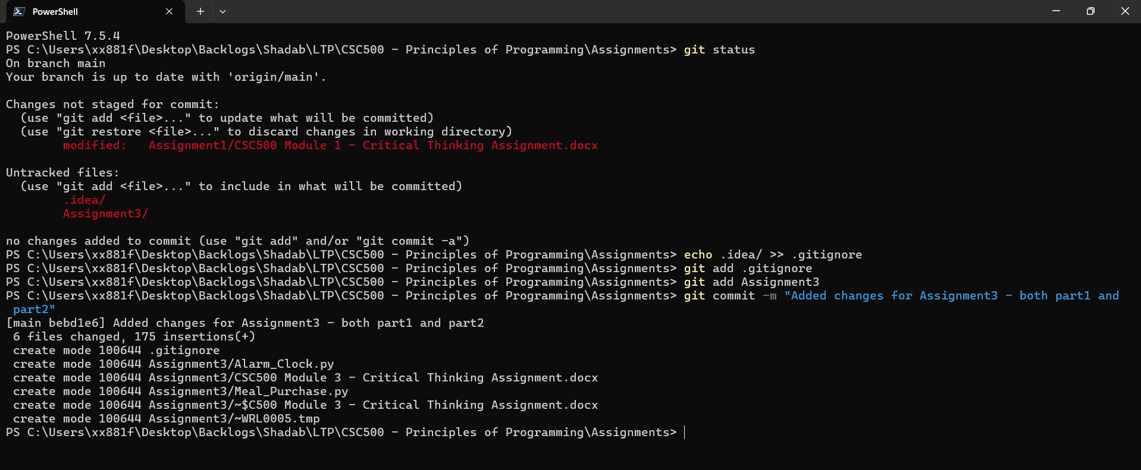

Pushing the Changes
git push origin main
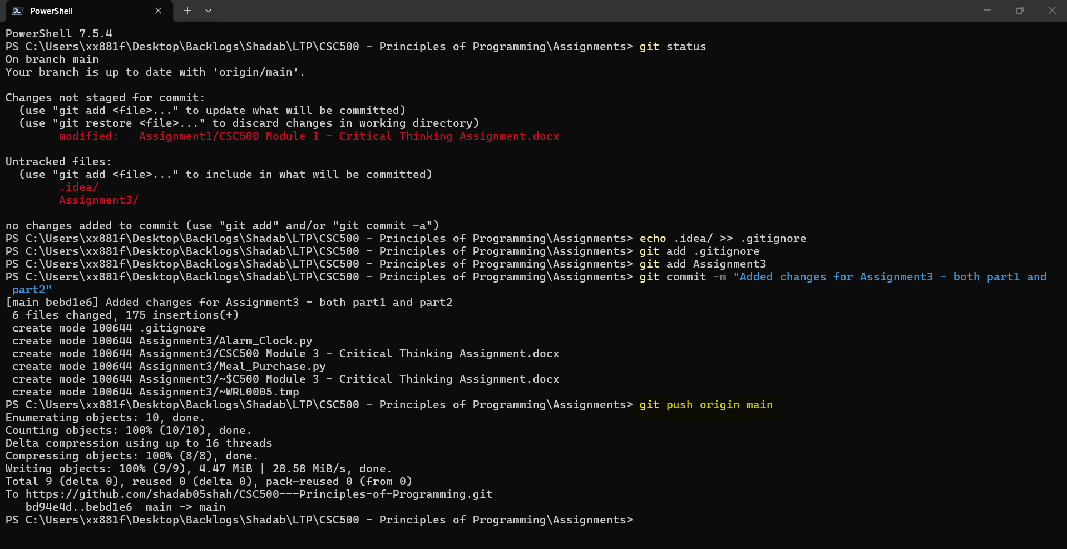

Checking Status
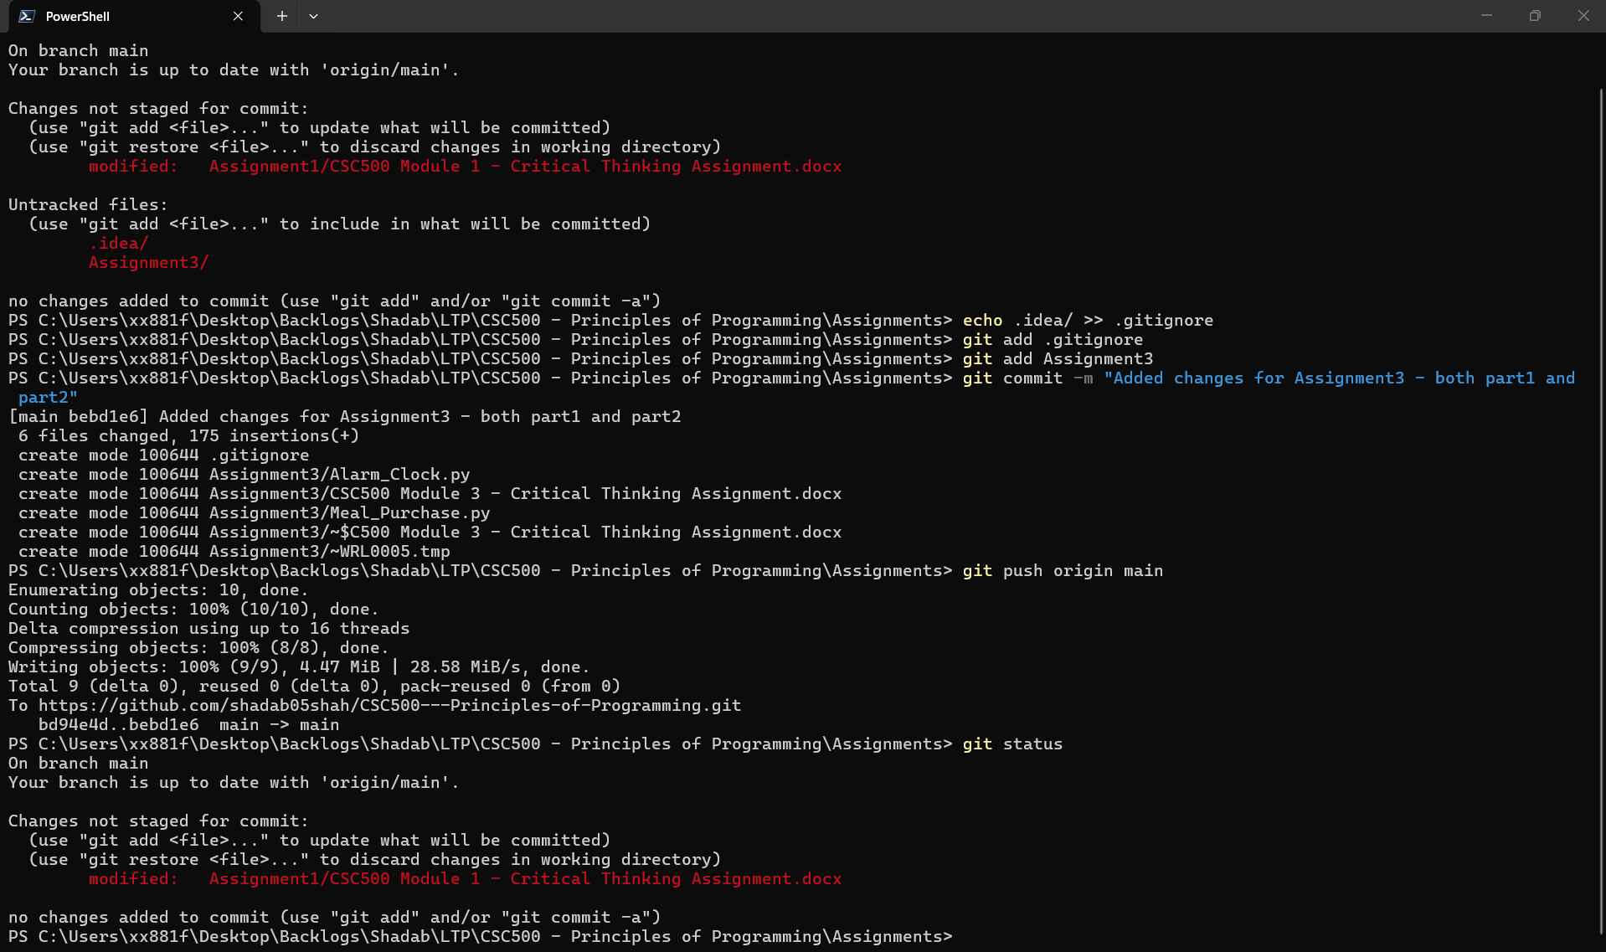

In Git-Hub repo page
